Modelling of Electron Air Showers and Cherenkov Light
- Mishev J. Stamenov

INRNE BAS, Tsarigradsko chausse72, Sofia1784, Bulgaria

Abstact: The CORSIKA 5.62 code is used for Monte Carlo simulation of extensive air showers, precisely of Cherenkov light flux at different observation levels. The lateral distribution function of Cerenkov light is obtained for the future experiments at Chacaltaya and Moussala. These calculations are carried out in different computer platforms. Some essential modifications in the computer code are made to reduce the calculation time and the dimension of output database. The additional computer codes are developed for data base processing. The comparison of the calculation possibilities and estimation for the future simulations is made. Especially the EGS4 code is used to obtain out the response of the water Cherenkov detector of the Blagoevgrad muonic telescope. An experimental direct check oh this model is made. Triggering and data acquisition system is developed. Experiment automation control system is also elaborate. The possibility for absolute calibration of water Cherenkov detectors is studied.

1.Introduction
Many problems in experimental cosmic ray physics need a precise simulation. The Monte Carlo simulations of electron photon cascades, which are part of extensive air showers, is one of the topic of interest. Most of the well known codes like EGS4 [1], GEANT [2], CORSIKA [3] are based on calculation of effective cross sections of the different processes in given geometry an the transportation step of the charged particle between two catastrophic energy losses. It’s clear that the possible reduction of the calculation time is of a big interest. At the same time the experimental possibility of the applied models verification permits to estimate the response of concrete detector and to develop a theoretical model based on observed phenomenon and to refine it for the detection system optimisation.

2. Code modifications
One of the principle characteristics of the extensive air showers is the lateral distribution function of Cherenkov light. The methodologycal investigation shows the possibility to obtain important information about primary cosmic ray radiation [4].
It’s clear that to reduce the important fluctuations due to the shower development one need to collect almost Cherenkov photons at given observation level. The results is

Fig.2 Flow diagram of modifications in EGS4

the output database file in the original CORSIKA became enormous for the high energies. For example for primary proton at 100 TeV for one shower the file is about 2 Gb. So some modifications in the source code are carried out, the redirection of the output in sense real time analysis of simulated data and record on a separate file. So we have used one very large detector 800x800m and on the basis of GHEISHA [5] and VENUS [6] like hadronic models the lateral distribution function of Cherenkov light at Chacaltaya observation level is obtained fig.1a and 1b.
The CORSIKA code is limited in single medium, geometry and use few atmospheric models. At the same time EGS4 gives the possibility to simulate electron photon cascades in different geometries, media etc… but in the original version the Cherenkov efect is not simulated.
Some modifications in the EGS4 user code was made particularly in AUSGAB subroutine (fig.2.). The additional subroutine CERE is for the Cherenkov photons production. When a charged particle penetrate in the medium and its velocity exceeds the local speed of light in the medium the Cherenkov photons are created according to the equation $N_{C}=\text{390}{\text{sin}}^{2}q_{c}$, θc is the Cherenkov angle, N_{c} are the emmited photons. We check first if the particle is in the region of interest. If the particle is charged we determine the Lorenz factor of the particle and if the charged particle is muon we replace the electron rest mass with the muon rest mass. This approach permits to simulate the effect in the case of the telescope. This is a good estimation because the muon energy losses in 10 cm of water are negligible. In CERE subroutine the energy losses due to the produced Cherenkov photons is not taken into account because it’s negligible compared to the losses by ionisation. The total number of created photons is given by the production per cm multiplied per the transportation step of the charged particle in the medium.

3.Direct experimental check
Before the amelioration of the model it's verification and limits determination are necessary. One of the possible verifications is the use of gamma source with energy above the threshold of Cherenkov radiation emission in water. We have used a ⁶⁰Co source, which creates Compton electrons with energy above the effect threshold.
An attempt to estimate the number of Cherenkov photons generated in water by gamma quantum is made with the following experimental setup (fig 3).

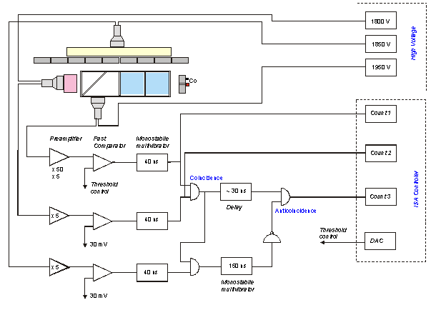
Fig.3 Experimental setup with discriminators and coincidence circuits

A gamma quanta radiated by the source passes through the collimator, the water tank and reaches the NaI scintillator. Due to the Compton scattering and production of electron-positron pairs into the water, electrons with energies high enough to radiate Cherenkov photons are generated. A part of the radiated Cherenkov photons after reflections by the mirror reach the cathode of photomultiplier PMT1. The discriminator outputs of the photomultipliers PMT1 and PMT2 are connected to a coincidence circuit. The amplitude distribution of the anode pulses of PMT1, which are in coincidence with the pulses from PMT2 is explored, changing the threshold of the discriminator. The plastic scintillator and the photomultiplier PMT3 are used as an anti-coincidence shield decreasing the number of cosmic ray background pulses. For three thickness of water, for 255 values of the threshold (10min measurements per experimental point) of discriminator are done two measurements of the distribution – with and without the ⁶⁰Co gamma source. The number of random coincidences is calculated for each point and subtracted from the counted value. Then from the distribution obtained with ⁶⁰Co we subtract the distribution without source. The triggering and data acquisition system are developed. Experiment automation control system is also elaborate.
An additional modelling of the Cherenkov photons trajectory in the tank permits a precise calculation of the tank efficiency. All the Cherenkov photons emitted in the detector are following until their absorption in the medium or their registration by the photomultiplier. The signal losses due to the reflection in tank's walls are taken into account. With calculated efficiency of Cherenkov photons registration and the photomultiplier efficiency we obtain the ratio of the theoretical and experimental results which seems similar as seen in fig.4. The little difference (the behaviour of the curve is not quite 1) is due to the different efficiency of registration of the small tank for level 10, 20 and 30 cm of water in the tank.
Fig.4 Experimental and theoretical responses of the water tank

This studies permits to make an efficiency estimation of Muonic Cherenkov telescope [7] and to elaborate methodology for an absolute callibration.
Other possible verification of the model is the comparison with another code for the Cerenkov effect simulation. A simple model of the atmosphere have been introduced in EGS4. The atmosphere is divided in 21 layers of 5 km thickness. The chemical composition is Nitrogen Oxygen and Argon. The variation of the refractive index is taken into account. This is important for the lateral distribution function of Cherenkov light. This simple model permits also to track the shower development. The angle of Cherenkov photons emission is also simulated with a full analogy with EGS4's UPHI subroutine. The comparison with CORSIKA code (VENUS [5] and GHEISHA [6] hadronic models have been used) is in a large energetic range for gamma primaries. We take into account only the total number of Cherenkov photons at sea observation level. The results are shown in fig.5.

4.Discussion
The ideology of most Monte Carlo codes used in radiation physics is first calculation of the cross sections for a given media and geometry and after that the transportation of the particles. One of the problems in these calculations is the reduction of computing time. The possibility to use some computers in network to calculate this data and the others to use this calculation like input data and make the particle transport data acqusition and analysis is studied. In EGS4 this is possible on UNIX based operational systems with help of EGS4 macros and scripts.
Other problem is the precise calculation of energy losses for medical dosymetry. We propose the algorithme of adaptive iterational step. One calculate analytically the losses, compare with obtained Monte Carlo result and if the difference is less then for example 1% the transport continue else the transportation step is recalculated the particle is once more at the beginning in the region etc… So we propose an iteration mechanism to calculate the transportation step of the particles. This process is most precise but the computational time became enormous.

Fig.5 Comparison between EGS4 and CORSIKA codes

Acknowledgements
We are thankfull at inj. G. Georgiev from INRNE and the team CREST/IRMA of the university of Franche Comte France.

References
[1] W. Nelson et al., SLAC Report 265, Stanford, CA 94305, (1985)
[2] R. Brun et al. GEANT3, Report CERN DD/EE/84-1, CERN, Geneva, (1987)
[3] D. Heck et al.report FZKA 6019, Forschungszentrum Karlsruhe, (1998)
[4] A. Alexandrov, S. Cht. Mavrodiev, A. Mishev and J. Stamenov, proc. 27 ICRC Hamburg 2001, 257-260, (2001)
[5] H. Feselfeldt report PITHA-85/02, RWTH Aachen, (1985)
[6] K. Werner Phys. Rep. 232, 87, (1993)
[7] E. Malamova et al. Proc. at 27 ICRC Hamburg 2001, 3952-3955, (2001)

