Organization of Computing for ALICE Experiment at JINR LIT PC Farm.

Iouri Minaev

|JINR PC LIT Farm configuration:

1 server:

Dual Pentium-III 600MHz, 512Mb RAM;
8Gb SCSI disk, 20Gb SCSI tape;
Mylex eXtremeRAID 1100 h/w RAID-5 170Gb,
real volume HDD 120Gb;
2 Intel Ether express Ethernet 100BaseT.

8 work station:

Dual Pentium-III 500MHz, 512Mb RAM;
8Gb SCSI disk;
Intel Ether express Ethernet 100BaseT.
Ethernet 100BaseT switch to 8 ports и Ethernet 100BaseT hub to 16 ports.

Operation systems.

ОС Linux 6.4 for server;
ОС Linux RedHat 6.1 with kernel linux 2.2.16 CERN configuration for work station;

CERN software.

PBS, CERNLIB 2000, Globus toolkit;

Special CERN software.

LHC++ включая Objectivity/DB;
cmsim и ORCA;

First install and test in november 2000 year
Root и Aliroot, GCC-2.95.2;

The two picture (fig1-2) presented structure software Root and Aliroot in LIT PC farm.
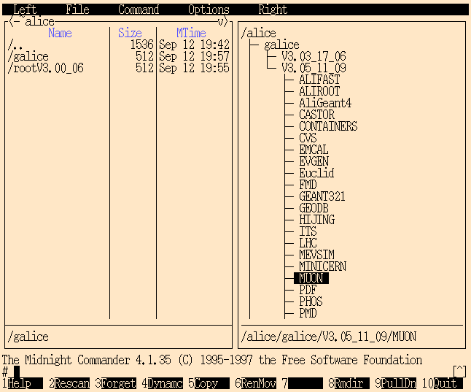
fig. 1

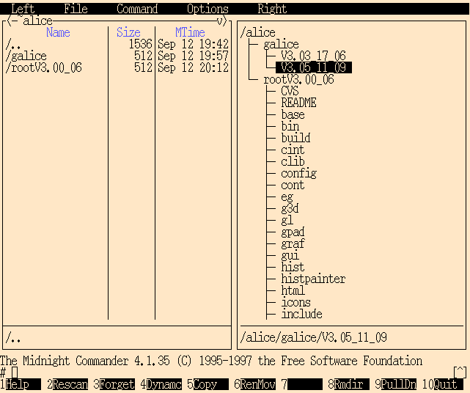
fig. 2

• for PHYSICS and DETECTOR Performance (at JINR)

- AliRoot - In the frame of the AliRoot the following problems are studied:

* ITS simulation .The main characteristics of the Silicon Pixel Detector (SPD):
⋅ cluster sizes (fig. 3);
⋅ space resolution in ((τ • Ψ) = x) and z (beam) directions (fig. 4)⋅

* Muon-Arm simulation - magnetic field map of the dipole magnet (fig. 5);

* Track recognition and reconstruction (Kalman filtering method) in the Time Projection Chamber (TPC) (fig. 6).

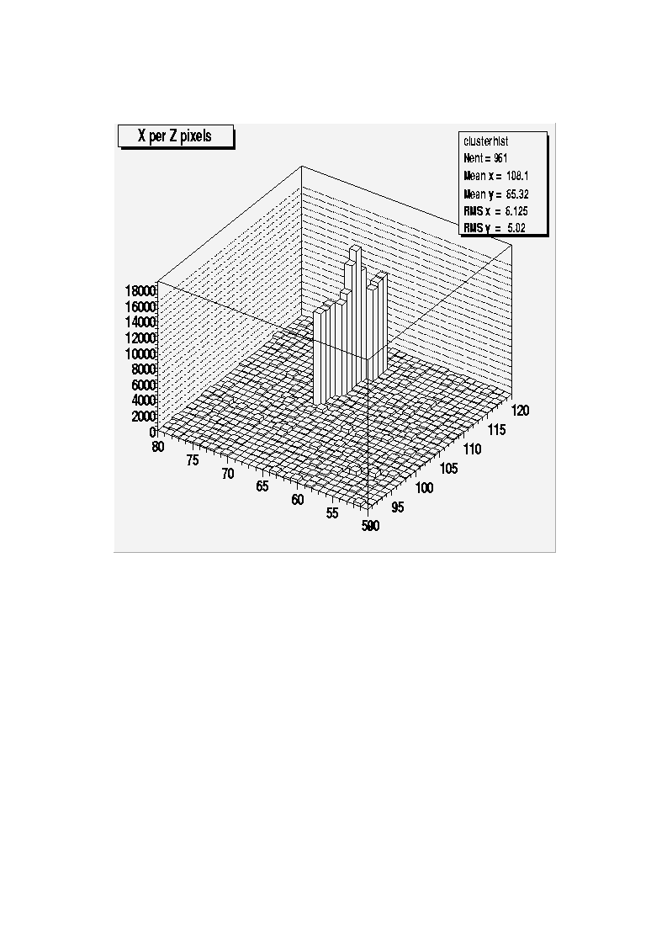
fig. 3
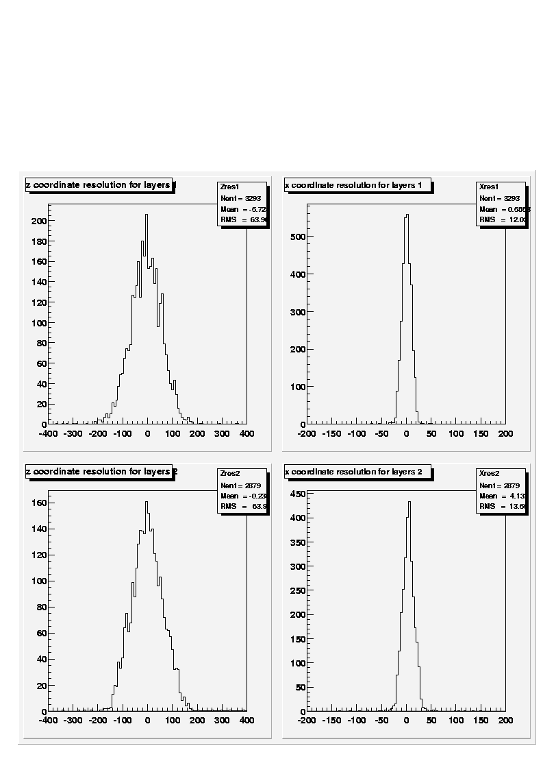

fig. 4
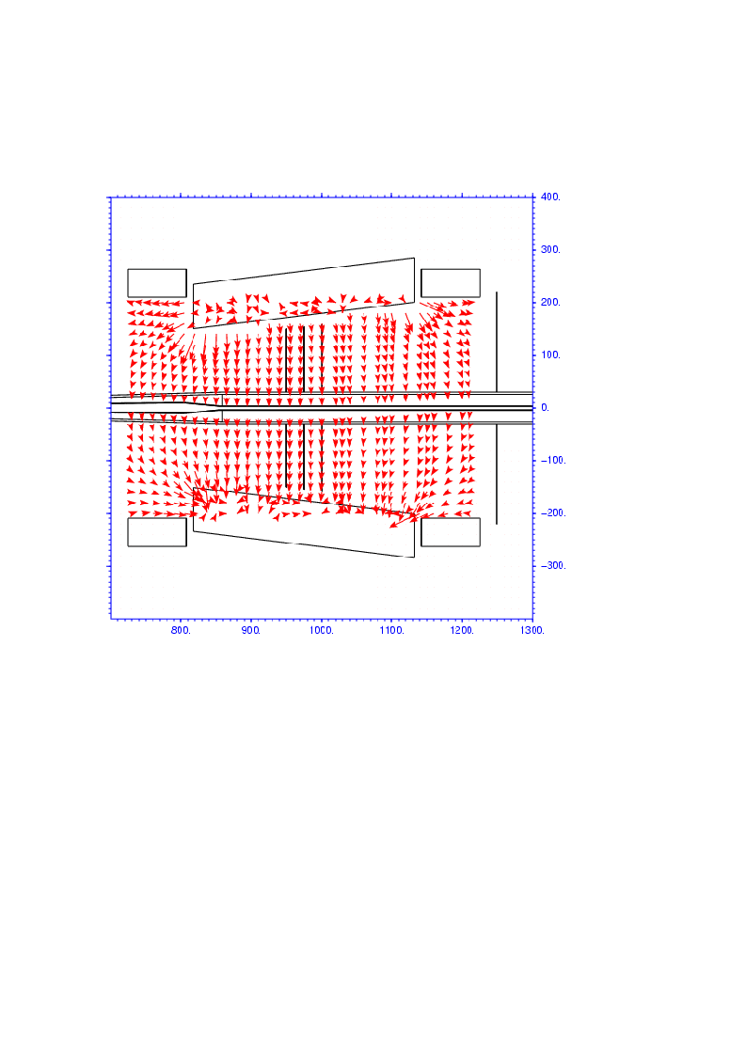

fig. 5
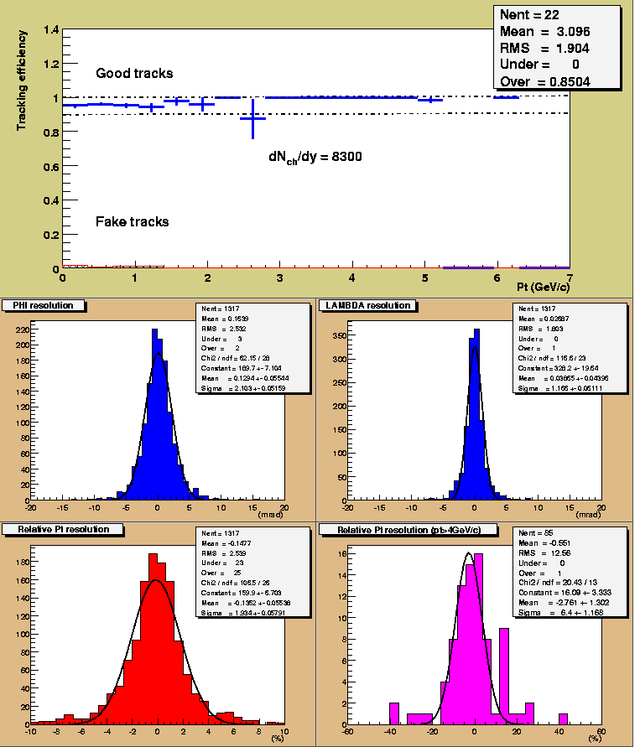

fig. 6

