V.Grebenyuk¹, A.Kalinin¹, Nguen Man Shat¹, A.Nozdrin¹, D.Podorozhny².

1.JINR, Dubna; 2.SNPI MSU, Moscow.

STUDY OF SCINTILLATOR STRIPS WITH WLS FIBERS FOR NUCLEON EXPERIMENT IN SPACE

Introduction
Plastic scintillating strips with embedded wavelength shifter (WLS) fibers are often used as active elements in high energy physics detectors[1-4]. The main advantage of such detectors is due to multicladding WLS fibers using. The light excited in the scintillator strips is in a blue wavelength band and travels not over only 1.5-2 m. It is quite different with multicladding WLS fibres. The fibers contain a special admixture which shifts the wavelength of the light to the longer green band, where fibers are transparent and the light is spreads up to 8-10 m.. As a result, the signal along the strips up to 30-40 cm may be considered as quite uniform.
Another advantage of such detectors is determined by small diameter of fiber. It permits to collect the light from many strips simultaneously to one small PMT (one- or multichannel).
All these useful properties of scintillator strips with WLS fiber read-out give a possibility of creating many different scintillator detectors for space experiments.
High- granularity scintillator calorimeters may be used for measurement of a shower profile and selecting between hadron and electromagnetic showers at a level of 1:10⁴, which is especially important in the space detectors[5]. Due to excellent timing properties of both plastic scintillators and PMTs, such detectors are supposed to be used in a trigger system of different space projects[5, 6].
In the NUCLEON space experiment [7] measurements of the charged particle spectrum in the range10¹¹-10¹⁵ eV are planned. Plastic scintillator strips with WLS fibers are supposed to be used in the trigger system of this experiment and for measurements of secondary particle coordinates behind the γ-convertor. For this aim we have studied the characteristics of these detectors together with some particulars of multichannel PMTs .
The tests with radioactive source and cosmic muons.
As a basic element, we used a plane of scintillating strips with WLS fibres
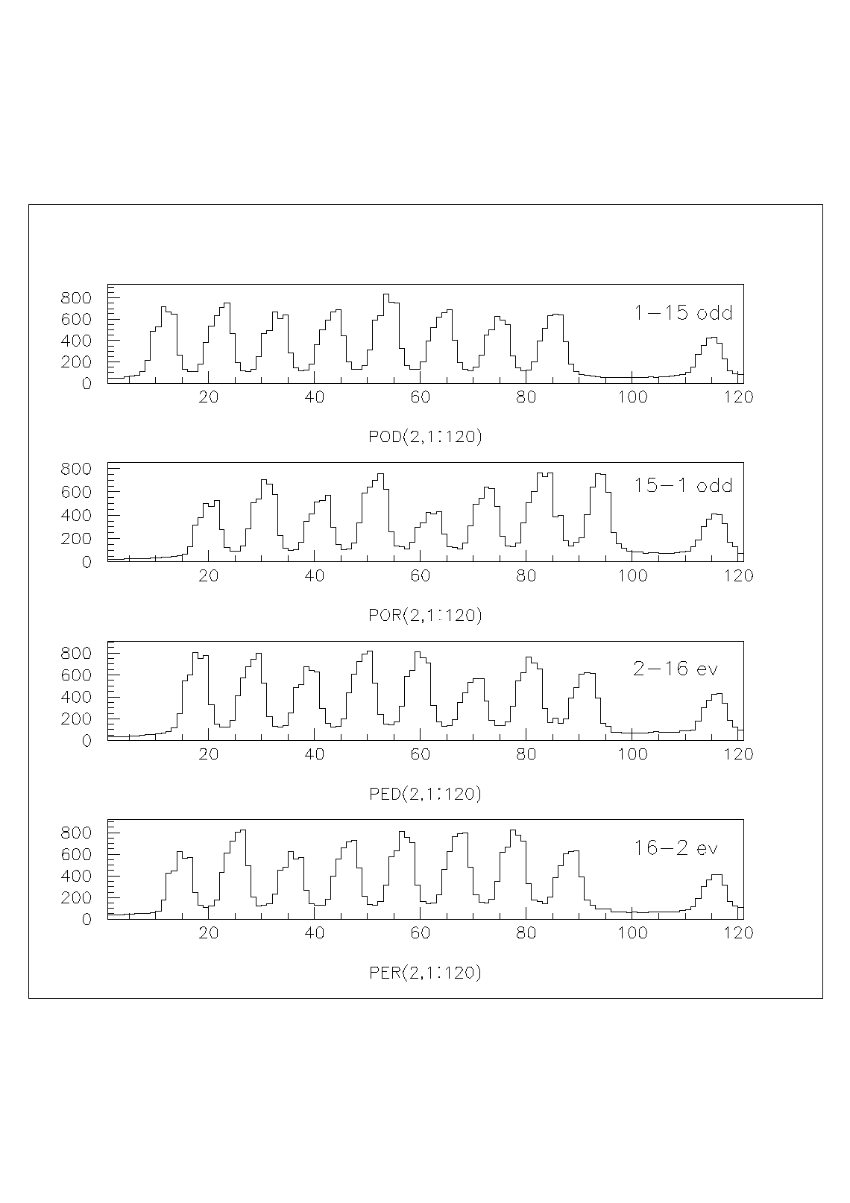
Fig. 1.The PMT output currents (in nA*10) in scanning across the strips by a ⁹⁰Sr source .The strip width is 7.5 mm. Two upper histograms are for odd strips ( left and right fibers), two lower ones are for even strips.
A single peak on the right is the signal of the reference strip.

consisting of 16 strips (16*0.75*0.5 cm³). Every strip had two fibers, which were separately embedded in grooves and glued by BICRON BC-600 optical glue. Before gluing the far end of the fiber is polished and covered by silver. Each strip was wrapped up in a white teflon film and then 16 strips were united into a plane. The opposite ends of the fibers were connected to PMT R5900 (Hamamatsu) through a special adapter. The latter kept the fibers in firm contact with the cathode.
One of the purposes of these researches was checking and estimation of uniformity and quality of strips. With this purpose each array of 16 strips was scanned across the strips by a radioactive ⁹⁰Sr source with activity about 2mKu. The source container had a narrow collimator (diameter 1 mm) and was placed at a distance of 1 mm from the strip surface. The only absorbtion matter between the source and the scintillator except the air was thin opaque band. Consequently, major part of the electron energy was absorbed in strips.
The PMT anode current was measured directly by nanoampermeter. In order to eliminate the current pile-up of neighboring strips, only 8 of 16 strips (every other strip) was simultaneously connected to the PMT. A typical picture of the PMT current is shown in Fig.1 for one plane. Two upper histograms are for 8 odd strip, the first histogram is for the left and the second one is for the right fibers. The bottom histograms are for even strips. The maximal PMT current is seen to be about 70 nA. (The dark PMT current is smaller than 1 nA). The distribution of maximal currents for 192 fibers (6 measured planes) is measured and RMS is equal to13% of the average value. The separate peak on the right side of Fig.1 corresponds to the reference strip. Its signal was stable during all measurements. To work with real detectors, the values of currents should be brought into the calibration data base for normalization of separate channel signals.
For high efficiency of the trigger and other systems in space experiments it is necessary to have sensitivity of those detectors better than 1 MIP (minimum ionizing particle). In order to determine the sensitivity of our strip detectors we carried out the measurements with cosmic muons using the same strip planes of 16 separate strips with two fibers in a strip.
The block diagram of the test layout is given in Fig. 2. It consists of three planes P1-P3, positioned one above any other, and an additional scintillating counter S1 under them. The signal of the counter S1 and the integral signal from the fibers of the upper plane P1 is used in coincidence for getting a system trigger signal. Only one fiber of the each P1 strip is used for trigger. The fibers are connected to the single-channel PMT R5900. Each second fiber of the planes P1-P3 is connected via a special adapter to the multichannel PMT R5900-00-M64 (Hamamatsu) cathodes for reading information about a signal amplitude in every separate strip. The PMT high voltage is selected to be 550 V. Besides trigger, the off line treatment of information was performed.

P1
P2
P3
Trigger

PMT
PMT
S1
Muon
PMT
R5900-
00M64

Fig.2. Block diagram of the cosmic measurement setup.

The conditions of event selection are the following
1. Only one particle is registered in P1 and P3
2. In each of the planes P1,P3 the amplitude of fired channel satisfies the conditions A _{i-1}<A _{i}>A _{i+1} and A _{i}>2 photoelectrons, where “i” is the number of the strip.
Such connection and the A_{i-1}, A_{i} ,A_{i+1} selection allow simultaneous collection of muon statistics from 16 strips of plane P2 with excluding very inclined tracks.
The signals from PMT anodes went to the electronics that was developed for the silicon tracker detectors of the AMS experiment. This electronics is based on the Viking microcircuits of the IDEAS company [9,10]. Every Viking chip VA_HDR1 contains 128 channels of low noise CMOS charge amplifier, CR-RC semigaussian shaper and a sample-and-hold circuit. All channels are connected to a flash ADC by means of an analog multiplexer that allows the sequential readout of the chip. The equivalent noise charge (ENC) of every channel is equals 660 + 4.2/ pF rms electrons at the 1.5 μs peaking time.
The results of measurements with cosmic muons are in Fig. 3. The spectra show the distribution of the ionization energy deposit by the muons crossing the scintillating strips of the plane P2. The X-axis is scaled in units of photoelectrons (ph.e.) created
Fig. 3. The spectra of cosmic muons of the scintillator strip detector with WLS fibers.

on the PMT photocathode. It is the usual practice, because these values include many factors difficult to measure (efficiency of light collection, a cathode photoefficiency) and it allows comparison of the given detector with other ones.
Note the particular feature of these measurements. The statistics of muon spectrum was collected from 16 different strips, each of them being connected to its own PMT channel followed by an amplifier. The strip uniformity was seen to be 13% and this error was included in the total result. As for PMT and amplifier gain its dispersion is more larger. So each particular channel was calibrated with the help of LED and the results of measurement were accordingly corrected. The average calibration coefficient was 4 channels/photoelectrons.
From the received spectra in Fig. 3 it is seen that the mean number of photoelectrons is in the interval is 7-9 which agrees with the other such measurements[8].

Linearity and sensitivity of the PMT at decreased high voltage
The required energy range for many cosmic experiments is from 1 MIP up to 500 MIP (from 1 muon up to electromagnetic shower maximum signal). But the PMT R5900-00-M64 anode has the maximum allowable pulse current I_{a} only about 0.3 mA and the output PMT signal for 1MIP is so small that working is possible only with amplifier. The suitable multichannel chip is the mention one from Viking family. But the Viking chips as any others have their own limit of input signals. Just the latter determines the linearity in case of combined work PMT and CMOS chip.
We have used VA_HDR1 chip with input limit 320 fC=2*10⁶ electrons [9,10].For coordinate, the PMT gain was decreased by slowing its high voltage up to 550V (instead normal 800-900 V). At E=550v the gain K= 2000 and the dynamic range of whole system equals 2*10⁶/2000=1000 ph.e.=100 MIP. The more wider range 500 MIP is possible also by using another Viking chip VA32_HDR2 with dynamic range 1650 fC [10]. This chip has 32 channel and the increased noise (2000 rms electrons), though.
As the PMT gain slows down the output signal decreases (1 photoelectron corresponds to 2000 electrons on the PMT output) and it is comparable with the contribution of the amplifier. In order to assess the sensitivity of the PMT with low voltage it was connected to a discrete charge sensitive preamplifier with noise as in a Viking chip. A spectrometric amplifier and an ADC were also used. The LED light was passed through the fiber to one of the PMT anodes. The other anode of the multichannel PMT were closed. The spectrum of the multichannel PMT R5900-00-M64 output amplitudes is shown in Fig.4.
For determining the mean number of photoelectrons N_{p.e.}, we used the formula
Fig. 4. The single photoelectron spectrum for the multichannel PMT R5900-00-M64 at a high voltage of 600 V. R_{A} is the anode resistance.

N_{p.e.}= - ln(N_{p}/N_{s}), where N_{p} is the number of events in the pedestal and N_{s} is the total number of events.( The formula follows from the Poisson law: the possibility of
having zero photoelectrons at mean Np.e. is P(0) =N_{p}/N_{s}=e^{-Np.e.}). In our case with the PMT R5900-00-M64 Np.e.=1.9 ph.e.
The dispersion of the main spectrum is determined by the Poisson statistics of a small number of photoelectrons, but the the pedestal width is mainly due to the noise
contribution of the system. The latter is not very large. The width of the pedestal is only doubled at the parallel connection of the addition resistor 200 kΩ to the preamplifier input (in this case the preamplifier noise increases about up to 2000 rms electrons ).
As we see, the sensitivity of the multichannel PMT R5900-00-M64 at V=550-600 V with a low noise preamplifier is enough for efficient registration of 1 MIP (9 ph.e.). At the same time the dynamic range is preserved up to 100 –500 MIP.
Fig. 4. The single photoelectron spectrum for the multichannel PMT R5900-00-M64 at a high voltage of 600 V. R_{A} is the anode resistance.

Conclusion
A possibility of using thin scintillator strips with WLS fibers in the NUCLEON space experiment is shown. Readout of light from the fibers by multichannel PMTs reduce the weight and power consumption , which is especially important for detectors in space. At present a full- scale prototype of a 64 strip plane is under preparation both for additional R& D with accelerator beams and for space qualification tests.

Acknowledgements
We are deeply grateful to R.Battiston, P.Levchenko and A.Olshevsky for their continuous support.
This work would not have been possible without assistance of our colleagues Z.Krumstein, A.Sadovski, L.Tkatchev and N.Zhuravlev. and we are very thankful to them.
References
1.The MINOS experiment, NuMI-l-337,1998.
2.M.Adams et al., NIM A366(1995),263-277.
3. CDF I I Technical Design Report, FNAL Pub-96/390E.
4 .The ALPHA Magnetic Spectrometer, NIM A419 (1988),p.295
5.V.Anosov et al., JINR Communication E13-99-31, Dubna 1999
6. http://www-glast.stanford.edu - GLAST proposal
7. J.Adams et al., 27th ICRC-2001 Proceedings, Hamburg 2001, p2188.
8. MINOS notes: NuMi-L-603, March 1, 1999; NuMi-L-250, Feb. 19, 1997
9. O.Toker et al., NIM A 340(1994),572
10. http:/www.ideas.no

.

