Multichannel printed circuit units for collecting detector signals

Authors: Chernikov V., Subbotin V., (RIPT)
Volkov Yu., Mishin Yu. (MEPhI)

The results of works on the creation of miniature multichannel printed circuit units (PCU) for an analog processing of multiwire detector signals are presented. The prototype versions of those PCUs were the topic of a report at the previous symposium [1].
The discussed PCUs measure 90 x 40 mm sq. and contain 16 channels, each of which is a series connection of a preamp, shaper and comparator, built on the basis of ICs. The mechanical design of PCUs is based on multi-layer PCBs, using SMT.

The detection of various types of radiation is an important part of many scientific and engineering tasks, arising in nuclear physics, physics of elementary particles, astrophysics, medicine, biology and oth.
The structural diagram of an up-to-date information and measuring system of a physical experiment can be described as follows: physical quantities (radiation intensity, pressure, temperature and so on) by means of primary transducers (detectors of ionizing radiation, scintillators, sensors of mechanical quantities, temperature and oth.) are converted into electric signals, which are fed into analog processing units (preamps, comparators, shapers, etc.) and, subsequently, to registration equipment and the equipment, collecting, processing, storing and displaying information. The number of primary transducers (detectors and sensors) makes up nowadays from hundreds to tens and hundreds thousand. Thus, for instance, the number of detector channels in the MDC of HADES (High Acceptance Di-Electron Spectrometer) reaches about 30000. That spectrometer , the construction of which is now being finished at GSI (Darmstadt, Germany), is created to investigate particles, generated at heavy nuclei (gold, platinum, etc.) collisions. It is obvious, that the link between detectors and registration equipment should be implemented with miniature analog processing units. The basic problem is namely the miniaturization of these units, which is possible through using analog ICs and multichannel PCUs, built on their basis.
Data on multichannel PCUs, intended for the analog processing of detector signals, were presented in earlier published articles [1…4]. The given paper presents some results of the authors’ subsequent works on creating miniature multichannel PCUs, particularly, a 16-channel PCU, made using 4 ICs: two 8-channel amplifier ICs and two 8-channel comparator ICs. The circuit diagram of the input part of PCU is shown in fig.1. The unit has 16 differential inputs with protection against overload.

Fig. 1
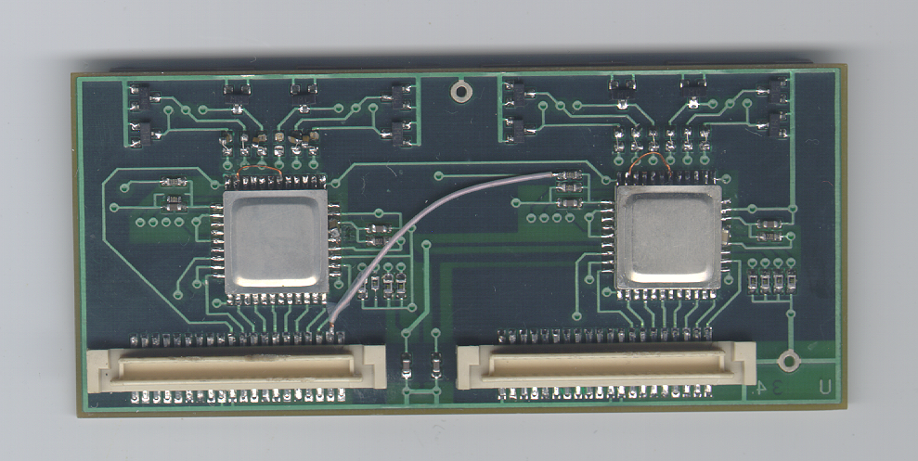
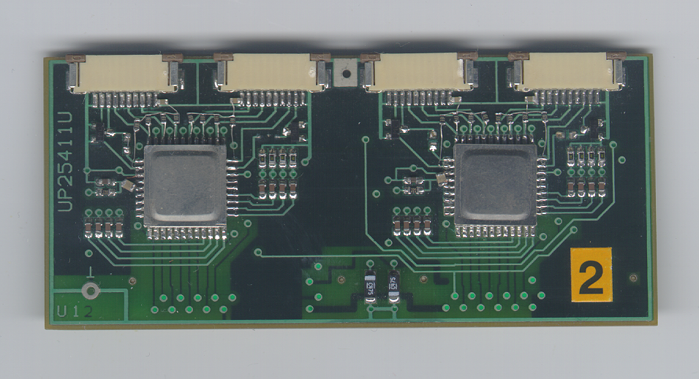
Fig. 2

The amplifier can function in two modes: as a current amplifier, driven by a high-resistance signal source, and as a voltage amplifier, driven by a low resistance signal source. As a current amplifier the IC is used, when amplifying the signals of a drift chamber. As a voltage one – in operation with a PMT or its solid-state analog (Solid-State Electron Multiplier). The load resistor can be then chosen in a wide range (for instance, from 50Ohm up to several kOhm); Consequently, the gain changes in a wide range. Its values are presented in the table. Signal shaping (tilted part shortening) is carried out by differentiation with an R-C circuit, connected between an amplifier and comparator. Originally the serviceability of a channel was checked in laboratory conditions at a drive by a pulse generator. The corresponding examples of signal scope traces are presented below.

The external view of the PCU is presented in fig.2. It is implemented on a 4-layer PCB, measuring 90×40 mm sq., using surface mount technology.
Fig.3 presents the signal scope traces of input signal, 5mV in amplitude (1 channel), of amplifier output signal, 1V in amplitude (2 channel). Gain is 200. The inverter output signal is 170 mV in amplitude. Rise-time does not exceed 10 ns.

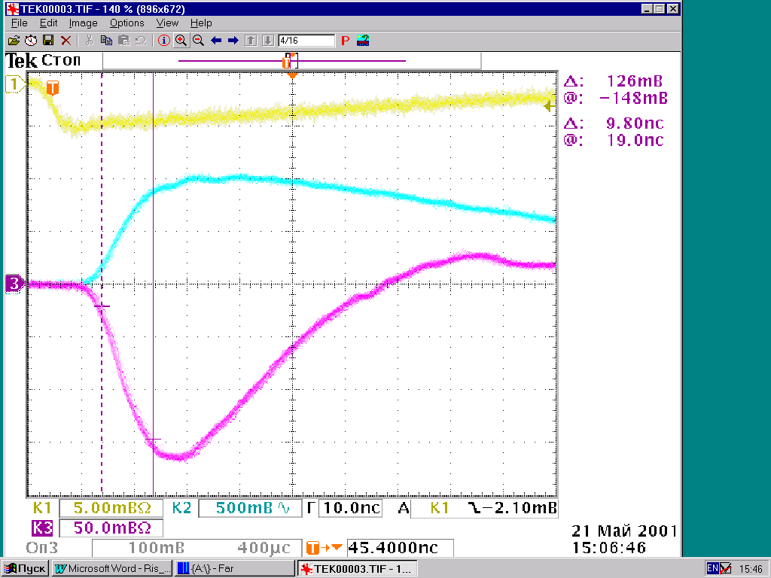

Fig. 3
Fig.4 presents the signal scope traces of input signal, 10mV in amplitude (1 channel), of amplifier output signal after differentiation with a capacitance of 10 pF (2 channel). Output signal amplitude equals 580mV.

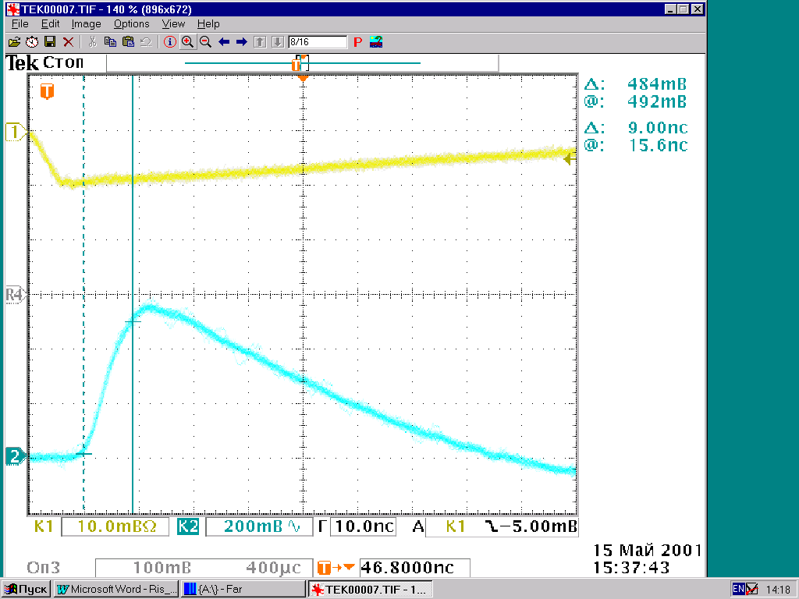
Fig. 4
The gain equals 58. Rise time does not exceed 9ns. The base level duration of the shortened output signal is 70ns. Undershoots are eliminated by a base line restoration (BLR) circuit, which is arranged at the comparator input.
The minimal threshold of comparator switch-over is determined by the noise level of amplifier and can be set not less than 25mV. Output signals comply with positive GTL-logic: they are differential with amplitudes of ~0.35V.
Both ICs (amplifier and comparator) have been implemented at Research Institute “Pulsar”, using an application specific semicustom array, created by a 6GHz planar npn bipolar technology.
The following table presents the basic parameters of the PCU under discussion.
Table
N | Name of parameter and unit of measurement | Value of parameter
1. | Number of channels | 16
2. | Supply voltage, V | ± 3
3 | Gain without shaping | 200
4 | Gain with shaping | 58
5. | Maximal output amplitude, mV | 2000
6 | Rise time, ns | ≤10
7. | Minimal comparator threshold, mV | 25
8. | Input noise of preamp, μV | 30
9. | Comparator output signals | GTL-logic
10. | Power consumption per amplifier channel, W | ≤0,04
11 | Power consumption per comparator channel, W | ≤0,04

The development of PCUs was carried out by specialists of Moscow Engineering Physics Institute and Research Institute of Pulse Technique in the framework of ISTC projects #254 and #1275.
Particularly, the presented PCU was used in the module, collecting data from the designed solid-state electron multiplier (SSEM). Fig.5 presents the assembly drawing of an 8-channel amplifier-discriminator for the analog processing of SSEM signals. Besides the PCU A1, the assembly drawing shows the connectors for input and output signals, SSEM supply circuits with adjustment in the range up to 200V, output shapers for the transition from GTL-logic to ECL-logic.
It is expected, that the designed units will be tested soon in an actual accelerator environment.

Fig.5
References
- E. Atkin, V. Chernikov, Yu. Mishin, V. Subbotin, S. Tsvetkov, Yu. Volkov. Printed circuit units for processing signals in nuclear experiments. Proceedings of the VII International Symposium on Nuclear Electronics, Varna, Bulgaria, September 15-21, 1997.
- E. Atkin, V. Chernikov, I. Ilyushchenko, P. Khlopkov, S. Kondratenko, Yu. Mishin, V. Subbotin, S. Tsvetkov, Yu. Volkov. Eight-channel PCBs for wire tracking detectors. Proceedings of the Third Workshop on Electronics for LHC Experiments, London, September 22-26, 1997, 463-465.
- E. Atkin, S. Kondratenko, Yu. Mishin, A. Pleshko, Yu. Volkov, A. Goldsher, V. Chernikov - Development of the printed circuit units for multiwire chambers. Proceedings of the Fifth Workshop on Electronics for LHC Experiments, Colorado, Sept. 1999, 499-500.
- E. Atkin, V. Chernikov, Yu. Mishin, V. Subbotin, Yu. Volkov. Units for collecting and processing preliminary the signals of multiwire chambers. Instruments and experimental techniques. Vol.42, 1999, №5, pp. 58-62.

