The Trigger and Read out System of the NUCLEON Space Experiment
G.L.Bashindzhagyan¹, V.M.Grebenyuk², A.I.Kalinin², L.G.Tkatchev², D.M.Podorozhnyi¹, A.G.Voronin¹
- D.V. Scobeltsin Institute of Nuclear Physics, Lomonosov Moscow State University
2.Joint Institute for Nuclear Research

At present the preparation is under way of the cosmic experiment NUCLEON^{/1/}, the aim of which is the investigation of the cosmic radiation and of its anomalous component. To be more concrete, the issue concerns the investigation of cosmic rays in the 10¹¹-10¹⁶ eV range.
The interest in this energy range consists in that the data of various experiments, performed both with balloons^{/2-5/} (JACEE, MUBEE, SUNRIKU, RUNJOB ) and with satellites^{/6-8/} (PROTON, SOKOL, CRN ), reveal a knee in the spectrum of cosmic rays in the range of 10¹⁵-10¹⁶ eV.
The experiments JACEE, MUBEE, SUNRIKU, RUNJOB were based on application of emulsion methods. In experiments PROTON and SOKOL electronic devices (calorimeters) were used for energy measurements and solid-state Cherenkov detectors were applied for charge identification.
All experiments, with the exception of RUNJOB, have already presented final results and can be considered completed. In the experiment RUNJOB, 40% of the available experimental data have already been analysed.
However, the statistics accumulated in these experiments is small, and the accuracy in determining the energy and charge within this energy range is low.
In the project NUCLEON, an essentially new approach is proposed to the investigation of nuclei in cosmic rays of high energies, E>10¹¹ eV. The approach proposed is based on a new method of measuring the energy of the primary particle by determining the spatial flux density of the secondary particles produced in a thin target in the primary vertex of inelastic interaction.
The essence of this method is illustrated by Fig. 1.
Interaction of the primary particle with the target results in the production of charged particles and γ-quanta. At a certain distance (sufficient for separating the secondary particles in space) from the target there is a lead or tungsten converter, in which the γ-quanta are newly converted into charged particles. The distribution of these particles, detected in microstrip semiconductor detectors, permits to calculate the parameter S(Е₀)=∑ η_{i}² N_{i} (where η_{i} – pseudorapidity and N_{i} – multiplicity in the selected i-th pseudorapidity interval) by which the energy of the primary particle may be reconstructed. Such a layout of the apparatus permits, for the first time, when kinematical methods of
energy determination are applied, to satisfy simultaneously the three conditions that hitherto hindered the application of these methods in CR investigations within the wide energy range of 10¹¹-10¹⁶ eV:
Fig.1. Layout of the device.
γ-converter
Primary
particle

target
ΣE_{γ}+ΣE_{ch}
1. Longterm operation (1-3 years) of the experimental setup outside of atmosphere.
2. The relatively low detection threshold (∼10¹¹ eV/nucleon).
3. The possibility of simultaneous analysis of the spatial distribution of both charged and neutral secondary particles produced in the first vertex of inelastic interaction.

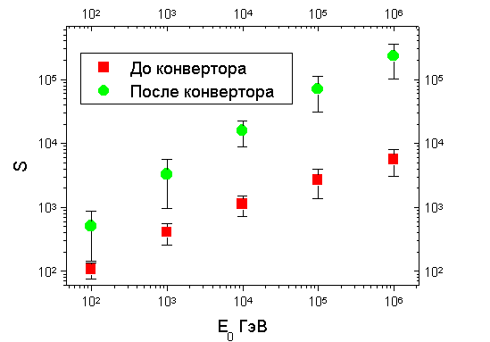
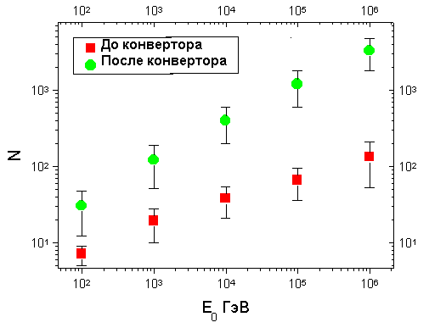
Fig. 2 presents the results of Monte Carlo simulation of variations in the multiplicity and in the S-parameter for various parts of the detector, depending on the energy of the primary particle.
Fig.2 The full multiplicity N and parameter S(Е₀)=
∑ η_{i}² N_{i} depending on the primary particle energy
On the basis of the simulation, a design has been developed for the detector, which is presented in Fig. 3. The detector is situated in a thermostabilazed container outside of the cosmic apparatus. The dimensions of the container impose rigorous limits on the dissipated power, which should not exceed 95 W. The SD1-SD5 are silicon detectors of total area 36x36 cm², composed of 60x60 mm² silicon plates. These plates are 300 μm thick. SD1 is a pad detector consisting of 15x15 mm² pads, while the others are strip detectors, and the strip pitch amounts to 30 μм in SD2 and SD3 and to 50 μм in SD4 and SD5. The strips in each pair of detectors are oriented along mutually perpendicular directions.
The readout of information in SD2 and SD3 is realized from every other 10-th strip, and the coordinate of the particle is determined by the relationship between the charges in adjacent channels. Such a readout method permits to significantly reduce the number of registration channels, as well as power consumption.
In SD4 and SD5 the charge is read out from each strip, since in these planes the number of particles within a narrow spatial interval has to be determined, instead of the coordinates of individual particles.
Thus, the number of registration channels amounts to 576 for SD1, 2400 for SD2 and SD3, 14200 for SD4 and SD5.
The CR1 chip, developed for the balloon experiment ATIC^{/9/} and for the satellite experiment PAMELA, is used for the registration channels of SD1. A special feature of this 16-channel chip consists in its wide dynamic range amounting to 2500 mip, however, it consumes much power, namely, 6 mW/channel, i.e. the total power consumption amounts to 3.5 W.
For the registration of information from the remaining microstrip detectors, the Viking chips are used of the IDEAS company, the power consumption of which does not exceed 1.5 mW/channel. Thus, the total power consumed by the electronics of these detectors is approximately 25 W.
For organization of the trigger, layers of scintillating strips are introduced into the experimental device. The strips of the detectors Sc11, Sc12 and Sc13, Sc14 are mutually perpendicular to each other and parallel to the strips of SD2,SD3 and SD4,SD5, respectively.
The light from the scintillating strips is measured with the aid of WLS-fibers. Each strip accommodates 2 fibers. One of these fibers is connected to the photocathode of a multichannel HAMAMATSU photomultiplier (PMT) R5900-00-M64, while the second fibers in the whole plane are connected to the photocathode of a single-channel HAMAMATSU PMT R5900. Such organization of the read out system makes
The UHIS detector system

Carbon target CT1
Scintillator layer Sc11

Carbon target CT2
Lead converter LC
Scintillator layer Sc12
Scintillator layer Sc14

Scintillator layer Sc13
Gap
360x360 mm²
350 mm350
SD2

SD3

SD1
SD4

SD5

Fig.3. Schematic view of the NUCLON instrument.

possible rapid registration of a particle passing through all four scintillating layers, and allows to obtain information on the total energy release in the layers and, also, to determine the orientation of the particle trajectory by the change in multiplicity (see Fig. 1). At the same time, the information from individual scintillator strips permits pointing to the chips of the microstrip detectors that contain useful information. Reading out only these chips decreases the readout time from the system and, also, reduces the number of ADCs required, since the possibility arises of enhancing the number of chips operating with a single ADC without increasing significantly the readout time.
A version of the block diagram of the trigger system is presented in Fig. 4. The multichannel PMT is connected to the 64-channel chip VA64_HDR4 of the IDEAS company. For noise reduction an integration time of 5 μs is applied in these chips. For matching the ranges of the input signals of the VA64 chips with the output signals from the multichannel PMT, the latter are operated with a reduced high voltage^{/10 /} of ∼600 V. Moreover, the reduced high voltage supply of the PMT reduces the dissipated power, that amounts to about 1 W/PMT.
The single-channel PMT are operated at a voltage of 1100 V, and for their output signals to comply with the range of the input signals of VA32, they are read out from the dinodes.
The signals from the anodes of the single-channel PM for each layer are sent to discriminators with controllable thresholds, and the signals from the dinodes numb.9 are sent to the first 4 inputs of the VIKING VA32_75 chip. This chip has an integration time of 75 ns and is controlled by the signal produced by a coincidence of the signals from all the 4 discriminators of the scintillator trigger planes. Besides, the coincidence signal triggers a monostable with a pulse length equal to the integration time of the VA64_HDR4 chip. During this pulse the signals from the discriminators of all the planes are recorded in a register, for recording possible superpositions of signals that are not very probable. The signal from the analog output of VA32 is sent to the selection unit, which contains ADC, registers
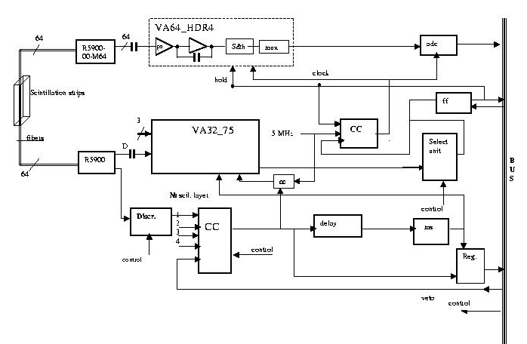
Fig. 4. The block diagram of the trigger system

of the layers and a digital discriminator, that compares the amplitudes of signals from the layers. When the amplitudes of signals from the successive planes exceed the amplitudes of signals from the preceding ones, a control signal is produced for the VA64 chip. The time required for producing this control signal does not exceed 1.5 μs.
After the readout of information from the VA64 chip, control signals are produced for the chips of the microstrip detectors, under which the scintillation strips are situated. The time required for producing these signals amounts to 15 μs.
The power consumption by the single-channel PMT amounts to 1.8 W, and by the entire trigger system not more than 13 W.
The design proposed for the space complex will allow to fully implement the program of the space experiment.

In conclusion, the authors express their profound gratitude to D.B.Pontecorvo, without the help of which the tgext of this work would not have been possible.

References
1.J.Adams , G.L.Basindzhagyan et al., “The NUCLEON-mission for Cosmic Rays Investigation”,27th ICRC proc., Hamburg, 2001, p. 2188.
2.JACEE collaboration 1998 Astrophys. J. 502 278; 1997 Proc. 25th ICRC (Durban) 4 1
3.Zatsepin V.I. et al., 1993 Proc. 23rd ICRC (Calgary) 2 13
4.Ichimura M. et al., 1993 Phys. Rev. D 48 1993
5.Apanasenko A.V. et al., 2001 Astrop. Phys (in press)
6.Grigorov N L et al., 1970 Yad. Fiz. (in Russian) 11 1058:; 1972 Space Res. 12 1617
7.Ivanenko I P et al., 1993 Proc. 23rd ICRC (Calgary) 2 17, 1989 Preprint NIIYaF MGU (in Russian) N89-29/106
8.Muller D et al., 1991 Ap.J. 374, 356
9.T.Guzik et al. Proc. 26th ICRC(Salt Lake City), 1999, V.5.p.9
10.V.Grebenyuk et al., “Study of scintillation strips with WLS fibers”(This conference)

