An Ultrasonic System for Remote Gas Monitoring

I M Rusinov  , K Burin and R Tsenov

Sofia University, Faculty of Physics, 5 James Bourchier Blvd

1164 Sofia, Bulgaria

Abstract. The system has been designed for monitoring the gas composition inside the big Cherenkov counter of the HARP experiment at CERN. This is necessary for controlling the filling gas (C₄F₁₀) purity as well as for safety reasons. The principle of measurement is based on the relationship between the speed of sound in a gas and its (effective) molecular mass. The speed of sound is obtained by two complementary methods which differ in their dynamic range and resolution: a) measurement of the propagation delay of the sound signal over a fixed distance and b) phase comparison of the emitted and received waves. For higher noise immunity and precision ultrasonic emitter and receiver, working at 40kHz are used. Besides, an electrochemical oxygen sensor with high selectivity and a temperature sensor are used to complement the measured data for better precision when resolving air and pure nitrogen. The transducers and sensors are mounted on a rail inside the gas chamber. They are connected via a gas-tight feed-through to an electronics unit placed outside. The latter is controlled by a host computer over a 30 m twisted-pair cable. The four measured signals are multiplexed and sent to the computer for further processing and analysis using the 4-20 mA current loop industrial standard. All calibration data are kept in the computer.

1. Introduction
The relationship between the speed of sound in a gas and the molar mass of the gas is described by the following formula:
$v=\sqrt{\frac{C_{p}}{C_{V}}\frac{\text{RT}}{μ}}$
, (a)

where C_{p} and C_{V} are the thermal capacities of the gas at constant pressure and volume, R is the universal gas constant, T is the absolute temperature, μ is the molar mass of the gas. If temperature and the ratio C_{p}/C_{V} are known parameters (depending on the gas, the ratio C_{p}/C_{V} ranges from about 1.7 for mono-atomic down to about 1.1 for poly-atomic gases) one can determine the molar mass of the gas from the measured speed of sound. This method is convenient and quite universal, however more selective complementary measurements might be
¯¯¯¯¯¯¯¯¯¯¯¯¯¯¯ e-mail: irusinov@phys.uni-sofia.bg

needed in some cases to definitely determine the kind of gas or gas mixture. Formula (a) allows also an easy and fast temperature measurement of a gas or gas mixture with constant composition.
Our goal was to build a sensitive system capable to control the purity of the working gas C₄F₁₀ contained in the chamber of the big Cherenkov counter of the HARP experiment at CERN. In the “sonar” block of our device we use an ultrasonic sound source and receiver with a resonance frequency of 40 kHz. This ensures high noise immunity against parasitic sounds in the gas chamber. Additionally an oxygen electrochemical sensor is used to determine with high selectivity any oxygen concentration in the gas environment. Temperature is also measured to take account for the temperature dependence of the speed of sound.

2. Description
The block-schematic is given in figure 1. The “sonar” portion is comprised of a master quartz oscillator, frequency divider, counter, digit-to-analog converter (DAC), synchronizing logic, amplifier and analog comparator and a phase comparator. The divider produces three synchronized signals with different frequencies. The lower two frequencies are used to drive the ultrasonic transmitter periodically (at 39 Hz) with bursts of 2 pulses at 40 kHz. The highest frequency (1.28/0.64 MHz selectable) is used to clock the gated counter. The latter works in a start-stop mode and measures the propagation time of the sound signal between the emitter and receiver. The number accumulated in the counter is latched in the DAC and transferred into an analogue value (voltage). This value is refreshed periodically with the 39Hz frequency. This is the so-called propagation delay method. The phase-difference method involves continuous mode of operation of the ultrasonic transmitter and comparison of the driving and received waves in the phase comparator. This method is more
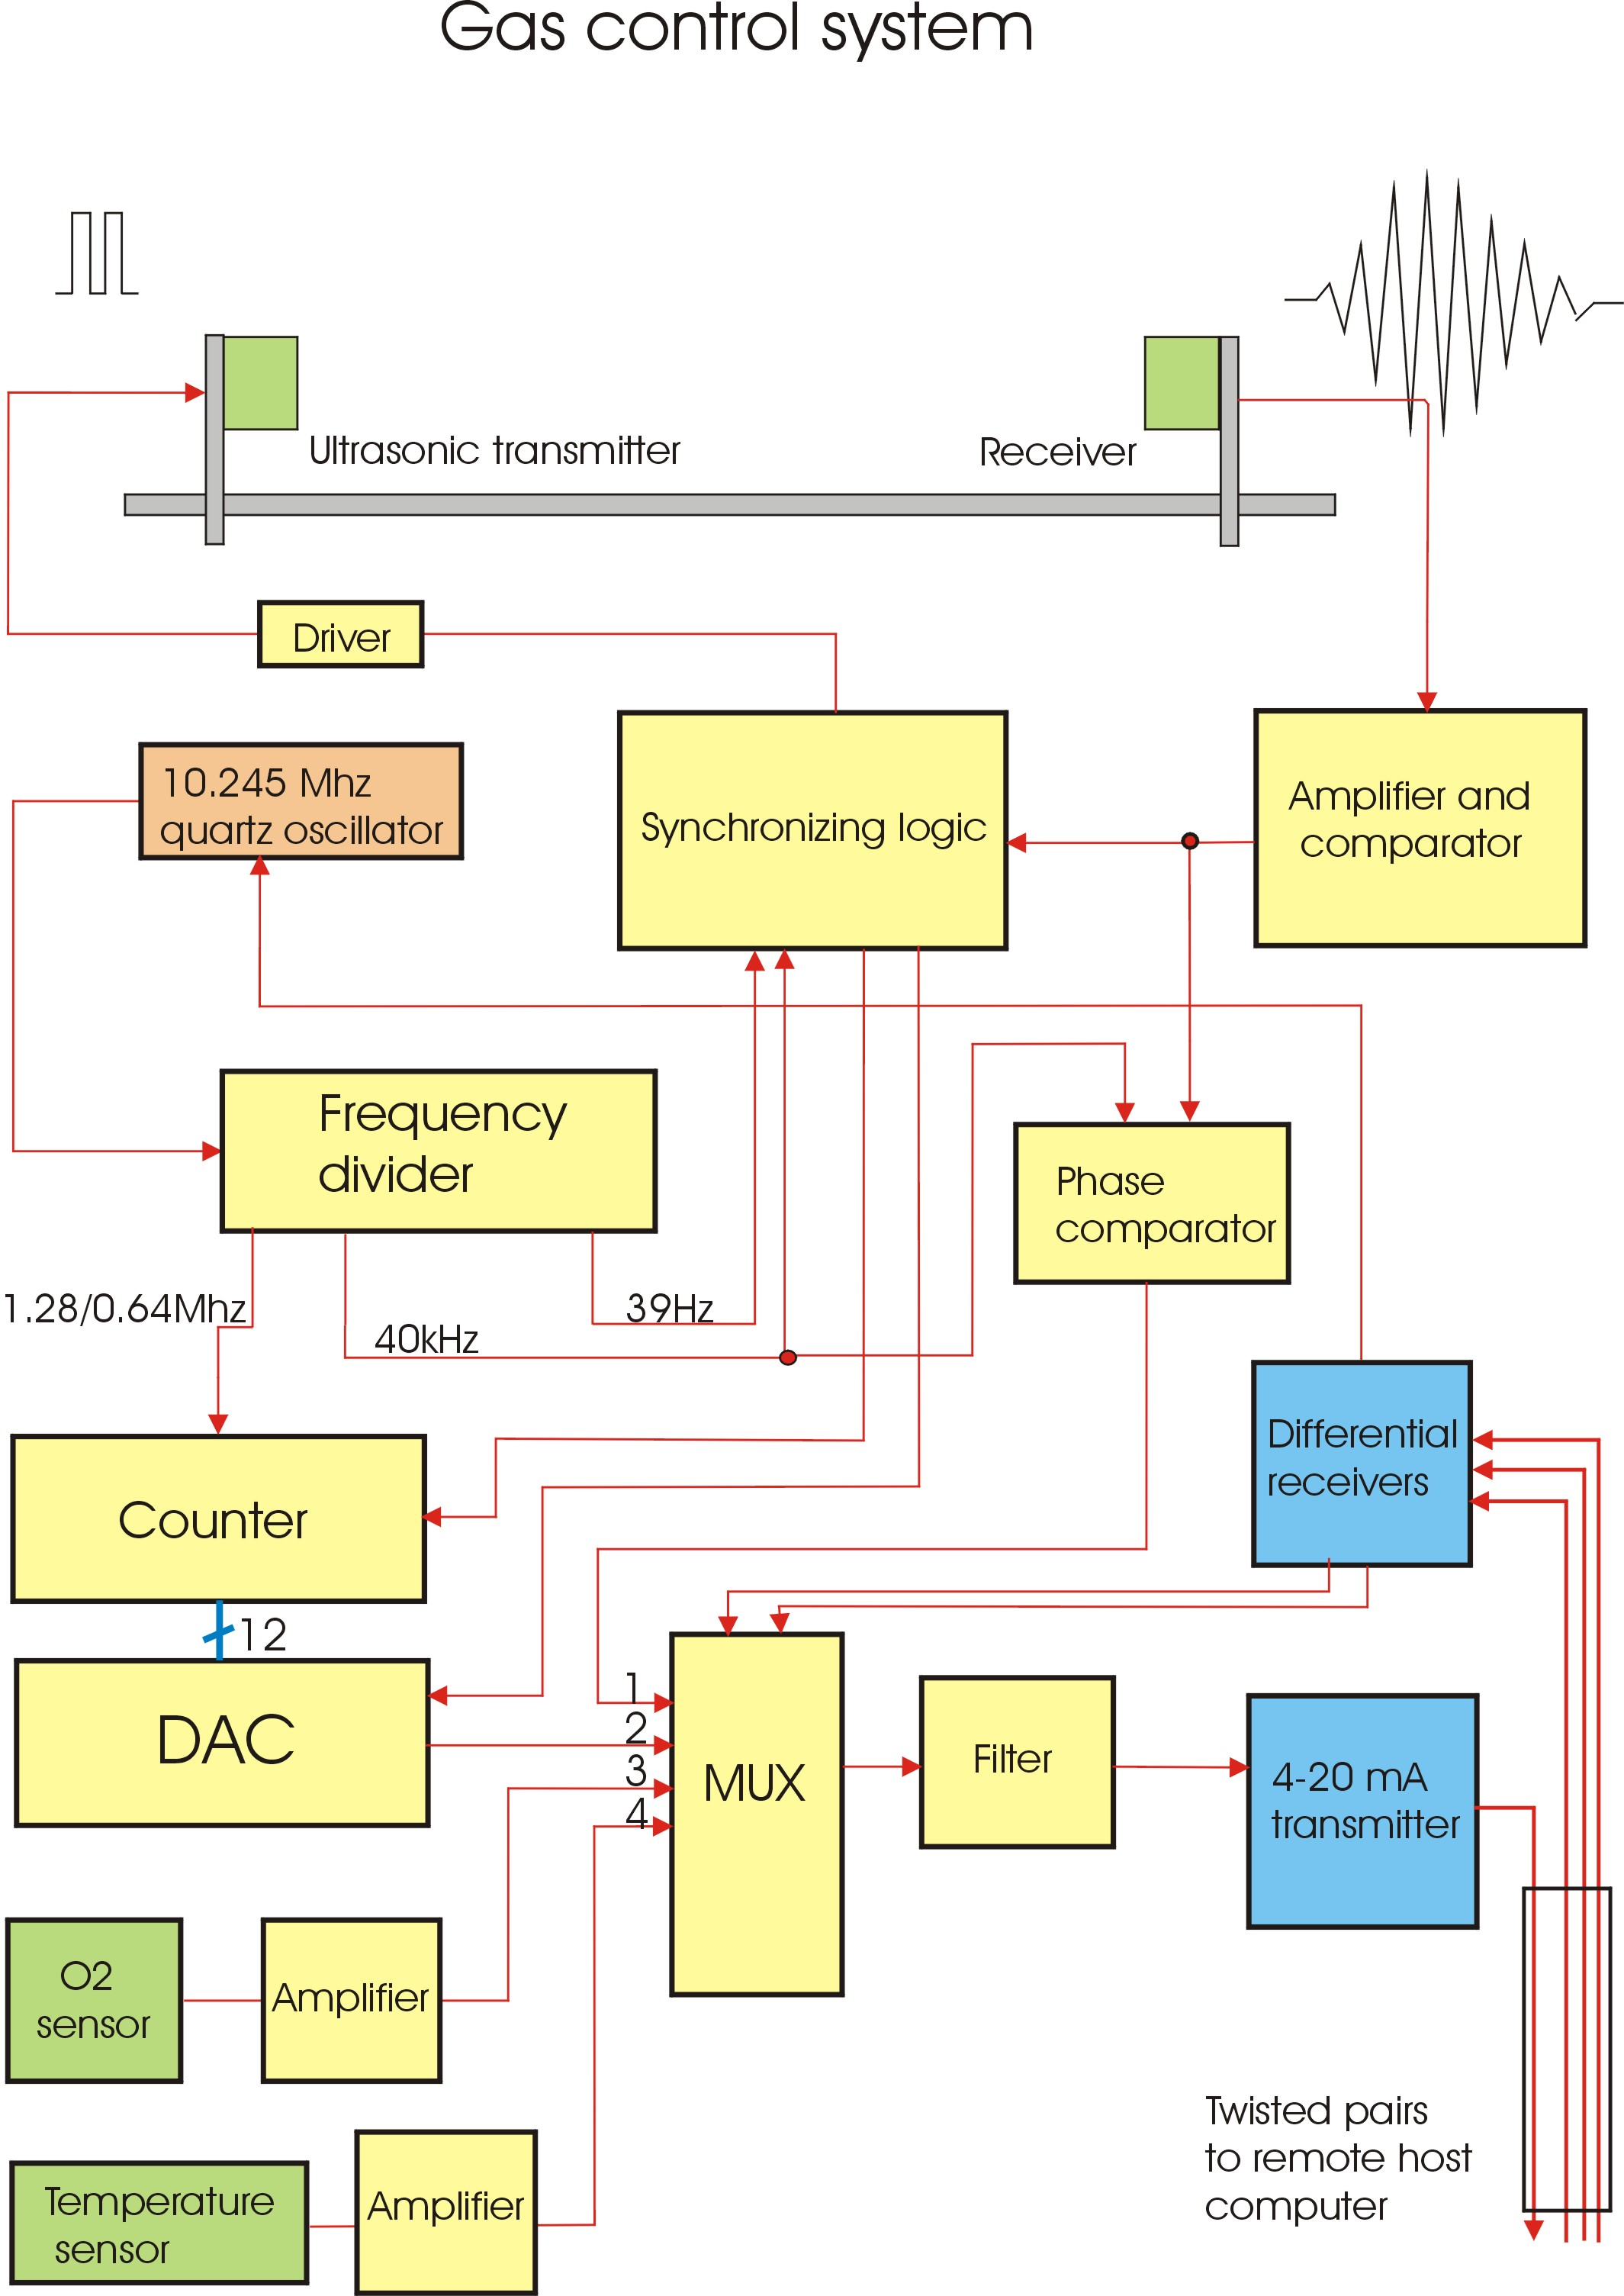

Figure 1. Block-schematic of the system for remote gas monitoring. Measured signals: 1, “dephasage”; 2, “propagation delay”; 3, “oxygen concentration”; 4, “ambient temperature”.

sensitive than the previous one due to accumulation of phase difference over the propagation path between transmitter and receiver. The temperature sensor is a temperature dependent current source, which delivers current proportional to the absolute temperature. The signal is amplified and appropriately shifted to match the needed range. The oxygen electrochemical sensor gives a low-voltage signal, which is amplified. Its temperature dependence is taken into account.
All four analog signals discussed so far are fed to the multiplexer (MUX), which passes the selected signal through a low-pass filter to the 4-20 mA current transmitter.
Finally the signal is sent over a long twisted pair cable to the remote host computer (programmable logic controller, PLC) where it is converted into voltage and measured. The control of the system is performed by a set of three differential logic signals received by the system from the computer. Two of these signals are used to select the analog signal to be transmitted and the third one is used to enable and disable the sonar. The signals are calibrated and the corresponding formulae are kept on the host computer.

3. Appendix

Main data:

Ultrasonic transducers: 400ET/ER180
Ultrasonic frequency: 40 kHz
Distance transmitter-receiver : 13cm
Time delay range: 0-3100 μs (at 1.28 MHz clock frequency)
Phase shift range 0-360º
DAC type :AD7545, 12 bit
Oxygen sensor: 70x CiTceL
Nominal range: 0-25% Oxygen
Expected operating life: 2 years in air
Response time: <= 15 s
Temperature sensor : LM334
Measuring range: 10-40 ºC
Interface: 3 differential logic signals, input
single 4-20ma current loop, output

